|  |
| --- |
|  |
| Module 3 Course Project |
|  |

|  |
| --- |
| Marie Debien  3/18/2018 |

**MODULE 3 COURSE PROJECT**

**MODULE 3 URL:**

<http://sotd.us/mariedebien/CIS4655C-MID/Module%203/Course%20Project/MDebien_Module%203.html>

**SCREEN SHOTS:**

**Galaxy S5 Screen Shot:**

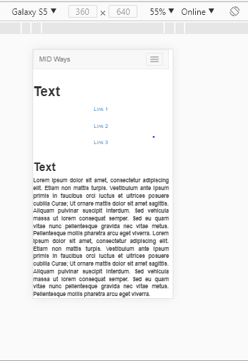

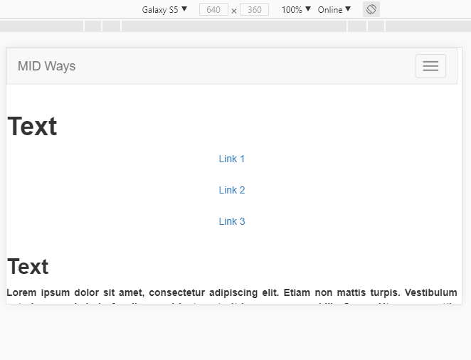

**iPhone 6 Screen Shot:**

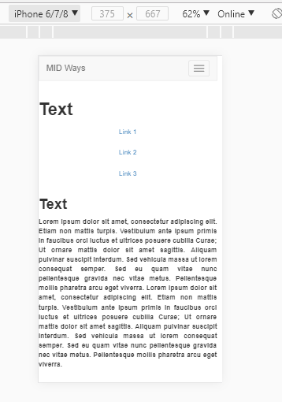

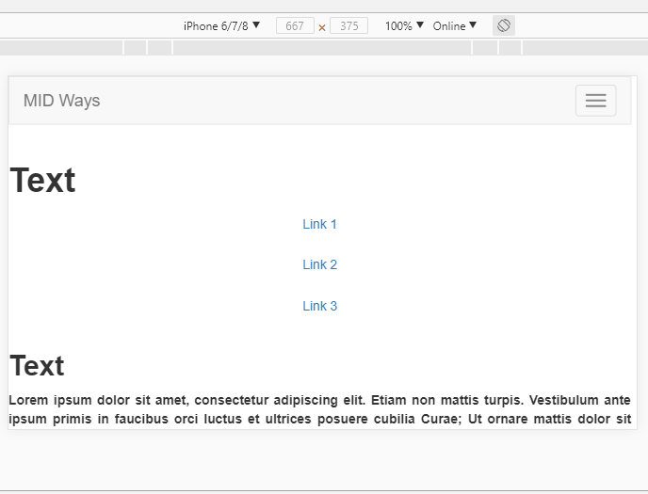

**iPad Pro Screen Shot:**

